DOCKER & AGENT INSTALLATION

## Revision History:

|  |  |  |  |  |
| --- | --- | --- | --- | --- |
| Revision: | 0 | 1 | 2 | 3 |
| Prepared by: | Arun Dev |  |  |  |
| Reviewed by: | Renjith |  |  |  |
| Owner  Approved by: | SETHU |  |  |  |
| Revision Date: | 25-07-2022 |  |  |  |

## Table of Contents

1. Introduction 4

2. Objective 4

3. Scope 4

4. How it works 5

6. Revision History 6

# Introduction:

Docker is an open platform for **developing, shipping, and running applications**. Docker enables you to separate your applications from your infrastructure so you can deliver software quickly. With Docker, you can manage your infrastructure in the same ways you manage your applications.

Since Cloud Infra Service (CIS) Team is responsible for the installation of docker and container agent for the Production Support team, it is important to keep the documented guidelines for the installation.

# Objective:

This document is indented to provide necessary guidelines for installation of docker and container agent

# Scope:

# This applies to all the CentOS 8 / RHEL 8 Servers

# Steps for Installing Docker

1. Run below dnf command to apply all the available updates and then reboot

**dnf update -y ; reboot**

1. Docker packages are not available anymore on CentOS 8 or RHEL 8 package repositories, so run following dnf command to enable Docker CE package repository.

**dnf config-manager --add-repo=https://download.docker.com/linux/centos/docker-ce.repo**

1. Once the docker ce repo has been configured successfully then run following command to verify which version of docker is available for installation using **dnf list docker-ce**

Eg:

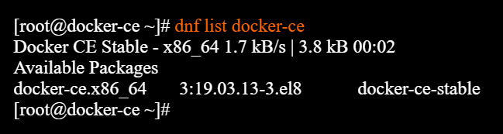

1. Use below command to install latest version of docker.

**dnf install docker-ce --nobest -y**

1. After the installation of docker, start and enable its service using the following systemctl commands

**systemctl start docker**

**systemctl enable docker**

1. Run the following command to verify installed docker version

**docker –version**

# Steps for Installing ECS Container-Agent

1. Download the appropriate Amazon ECS agent file for your operating system and system architecture and install it.

**For rpm architectures:**

* **curl -O** [**https://s3.us-east-1.amazonaws.com/amazon-ecs-agent-us-east-1/amazon-ecs-init-latest.x86_64.rpm**](https://s3.us-west-2.amazonaws.com/amazon-ecs-agent-us-west-2/amazon-ecs-init-latest.x86_64.rpm)

**NB: Region should be selected as per the configuration given by the user.**

* **sudo yum localinstall -y amazon-ecs-init-latest.x86_64.rpm**

1. To register the instance with a cluster other than the default cluster, edit the /etc/ecs/ecs.config file and add the cluster name.

**EG:** ECS_CLUSTER=*MyCluster*

* **Open the console, and go to ECS .**
* **Template cluster can be created according to the requirement. In our case we are using Networking Only Cluster.**

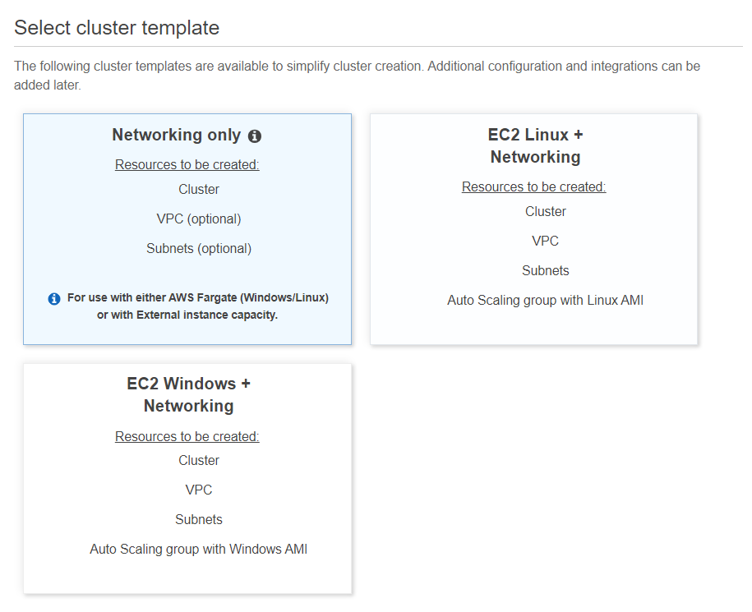

* **Create an empty cluster. Cluster name can be given as per the user discretion.**

**NB: Cluster name given to the console and CLI should be same.**

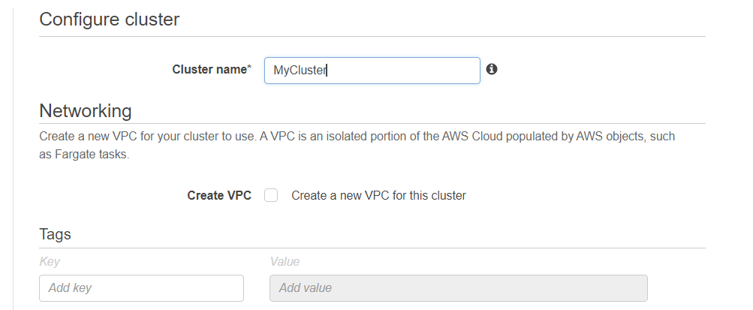

**Revision History**

|  |  |  |
| --- | --- | --- |
| Revision By | Date | Approved by |
|  |  |  |
|  |  |  |